

Technical Sheet
Click here to email us, or call (972) 961-4655 to speak to a sales representative.

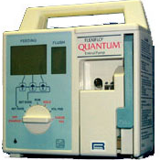
Ross Medical Quantum Enteral Pump

Refurbished, 1 year warranty

Product Description
The Ross Quantum Enteral Pump offers the unique ability to flush the enteral feeding set and indwelling feeding tube each hour with a 25 ml. flush solution. It also offers automatic priming, dose limit, volume accumulations for both enteral and flush solutions.

FEATURES:
- Rotary peristaltic operation.
- Rate Parameters: 1-300 ml/hr in 1 ml incr.
- Occlusion Pressure: 15 PSI
- Accuracy: ± 10% or ± 0.5 ml, whichever is greater
- BatteryLife: 8 hours at 125 ml/hr.
- Recharge Time: 8 hours
- Alarms: Occlusion, Empty, Dose Complete, Low Battery, Door/Cassette, Set Rate

