

Technical Sheet
Click here to email us, or call (972) 961-4655 to speak to a sales representative.

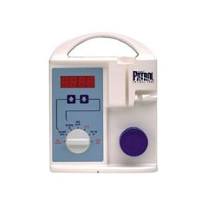
Ross Medical Patrol Enteral Pump

Refurbished, 1 year warranty
PRODUCT SPECIFICATIONS
Dimensions: | 8.25"H x 7.5"W x 6"D
Weight: | 7.2 pounds
Operating Range: | 1-300 ml/hr in 1 ml/hr increments
Accuracy: | ±10%
Power: | 100-130 VAC, 47-63 Hz, 4 Watts
Battery: | Rechargeable sealed lead-acid
Recharge Time: | 8 hours turned off; 12 hours running
Battery Life: | 8 hours at 125 ml/hr when fully charged

