

Technical Sheet
Click here to email us, or call (972) 961-4655 to speak to a sales representative.

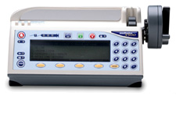
Medex Medfusion 3500

Refurbished, 1 year warranty
PRODUCT SPECIFICATIONS
Dimensions: | 10.5"W x 5.1"H x 5.5"D
Weight: | 3.8 lbs without pole clamp
Accuracy: | ±2% excluding syringe variations
Flow Rate Range: | 0.01 ml/hr to 1130 ml/hr depending on syringe size
Delivery Modes: | ml/hr, body weight, mass, volume over time, customer dilution, and intermittent
Delivery Options: | Loading Dose, Bolus Dose, Standby, Volume Limit, and KVO Rate
Power: | 100 to 240 VAC, 50/60 Hz, 30VA  Internal rechargeable battery  Optional external DC Input, 6-14 VDC, 7 Watts  Safety Class II - Type CF
Internal Battery Capacity: | 10 hours at 5.0 ml/hr with 60 ml syringe
User Defined Delivery Libraries: | Four Libraries with 16 profiles per library
MR Tested: | May be used in MRI Rooms with static magnetic fields up to 150 gauss
Options: | PharmGuard™ Error Reduction Software for programmable limits

