

Technical Sheet
Click here to email us, or call (972) 961-4655 to speak to a sales representative.

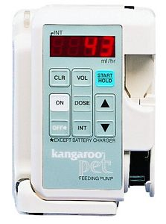
Kangaroo PET Enteral Pump

Refurbished, 1 year warranty
PRODUCT SPECIFICATIONS
Dimensions: | 5.75"H x 3.81"W x 2"D pump only  6.25"H x 4.5"W x 4.6"D with charger
Weight: | 1.4 pounds pump only  2 pounds with charger
Battery: | Rechargeable
Charge Time: | "Quick Charge" in 6 hours
Battery Life: | 14 hours at 125 ml/hr
Operating Range: | 1-75 ml/hr in 1 ml/hr increments  75-400 ml/hr in 5 ml/hr increments
Accuracy: | ±10%

