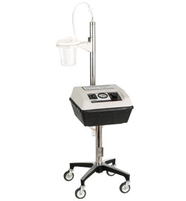
Aeros Moblvac III CS Portable Suction Unit, 757000

Refurbished, 1 year warranty

Product Specifications
Vacuum Range: 0 to 550mm Hg
Free Air Flow: 38 LPM minimum
Pump: Fan cooled rotary carbon vane type
Canister: Disposable plastic with mechanical shutoff
Capacity:1200cc standard
Tubing:14" with bacterial filter
Vacuum Regulator: Rotary type on panel
Vacuum Gauge: Calibrated in mm Hg
AC:
- - 120 volts, 60 Hz, 3A
- - 220 volts, 50 Hz, 2A
Weight: 32 lbs
Dimensions: 28"H x 14"W x 16"D

