

Technical Sheet
Click here to email us, or call (972) 961-4655 to speak to a sales representative.

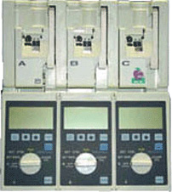
Hospira/Abbott Plum XL3
Infusion Pump
Refurbished, 1 year warranty

PRODUCT SPECIFICATIONS
Dimensions: | 13.75"H x 12.2"W x 7.5"D
Weight: | 20 lbs. with batteries
Casing: | High Impact Plastic
Delivery Rate Range: | 0.1-99.9 ml/hr in 0.1 ml increments  100-999 ml/hr in 1 ml increments
Volume to be Infused Range: | 0.1-99.9 ml in 0.1 ml increments  100-9999 ml in 1 ml increments
KVO Rate: | The lower of 1 ml/hr or the primary delivery rate
Occlusion Range: | 10 psig (+5, -2 psig)
Power Requirements: | 100-130 VAC, 47/63 Hz, less than 60W
Power Cord: | Hospital grade AC cord, 10ft long
Fuses: | 1.0 A, 250V, slow blowing
Batteries: | Rechargeable and sealed, lead acid 8V batteries
Battery Life: | A fully charged battery set will provide operating time of approximately 4 hours when all pumping units operate simultaneously at a rate of 125 ml/hr or a cumulative delivery of 1000 ml at any combination of rates and pumping units.
Battery Recharge: | Recharge takes approximately 6 hours when the device is turned off.

