Infusion Devices - Ambulatory:
Abbott APM II

The Abbott Pain Manager II (APM II) is a single-channel infusion pump that delivers analgesia to patients in the hospital, in outpatient treatment centers, and in the home.  Dimensions: 6.75H x 4.0W x 2.3D in (17.1 x 10x2 x 5.8 cm),  Weight: Approximately two pounds (1.0kg)  Power Sources: AC: Wall plug-in AC power supply List 13036 with 12 foot (3.6 meters) cord and molded plug.  Input: 115 VAC, 60 Hz, 0.18A.  Output: 12 VDC, 400 mA.  Battery: Two 9-V batteries |  | 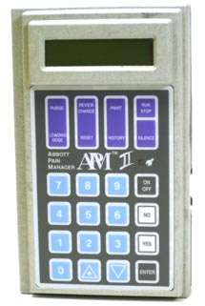
Operating Range:
Volume: |  | Minimum: 0.1 mL  Maximum: 1000 mL
Bolus & PCA: |  | Minimum: 0.1 mL  Maximum: 25.0 mL
Lockout Time: |  | 5 to 999 minutes
Loading Dose: |  | Minimum: 0.1 mL  Maximum: 25.0 mL

